Name : Anubhav Bhardwaj Section : K

Roll No : 181500107

# **Sub** : PHP

Q1. Explain the concept of Nested table , Row span and colspan attributes in HTML 5, Create a table for the following data i.e PRODUCT NAME , PRODUCT ID, PRODUCT QUANTITY, PRODUCT PRICE. in last you have to show a TOTAL AMOUNT IN COLSPAN.

**Ans:-**

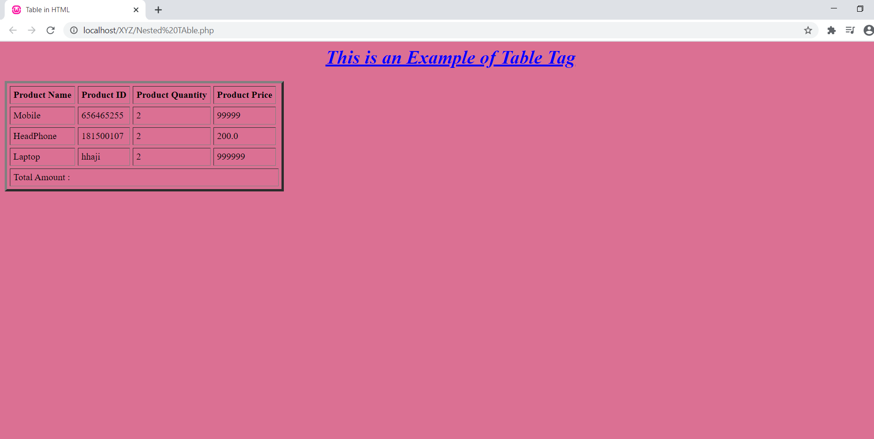

<html>  
<head>  
 <title> Table in HTML </title>  
</head>  
<body bgcolor="orange">  
<h1 style="color:blue" align="center"> <u><i>This is an Example of Table Tag</i></u></h1>  
<table border="4" cellpadding="5" cellspacing="5">  
 <tr>  
 <th>Product Name </th>  
 <th> Product ID </th>  
 <th>Product Quantity </th>  
 <th> Product Price</th>  
 </tr>  
 <tr>  
 <td> Mobile</td>  
 <td> 656465255 </td>  
 <td> 2</td>  
 <td> 99999</td>  
 </tr>  
 <tr>  
 <td> HeadPhone</td>  
 <td> 181500085 </td>  
 <td> 2</td>  
 <td> 200.0</td>  
 </tr>  
 <tr>  
 <td> Laptop</td>  
 <td> hp </td>  
 <td> 2</td>  
 <td> 999999</td>  
 </tr>  
 <tr >  
 <td colspan="5"> Total Amount : </td>  
 </tr>  
</table>  
</body>  
</html>

Q2. Write a PHP Script to print all natural numbers from 1 to n. - using while loop

**Ans:-**

<html>  
<head>  
 <title> Natural Number 1 to n</title>  
</head>  
<body bgcolor="Orange">  
<h1 align="center" >Natural Number</h1>  
<form method="POST">  
 <label>Enter Range of Number </label>  
 <input type="number" name="range" size="10" >  
 <input type="submit" name="submit" >  
</form>  
<?php  
$range=$_POST['range'];  
if(isset($range)){  
 $i=0; while($i<=$range)  
 {  
 echo "$i ";  
 $i++;  
 }  
}  
?>  
</body>  
</html>

Q3. Write a PHP Script to print all natural numbers in reverse (from n to 1). - using while loop

**Ans:-**

<html>  
<head>  
 <title> Reverse Natural Number n to 1</title>  
</head>  
<body bgcolor="Orange">  
<h1 align="center" >Reverse Natural Number</h1>  
<form method="POST">  
 <label>Enter Range of Number </label>  
 <input type="number" name="range" size="10" >  
 <input type="submit" name="submit" >  
</form>  
<?php  
$range=$_POST['range']; if(isset($range)){  
 while($range>0)  
 {  
 echo "$range ";  
 $range--;  
 }  
}  
?>  
</body>  
</html>

Q4. Write a PHP Script to print all alphabets from a to z. - using while loop

**Ans:-**

<html>  
<head>  
 <title> a to z</title>  
</head>  
<body bgcolor="Orange">  
<h1 align="center" >Print a to z</h1>  
<?php  
$range='a';  
$n=1;  
 while($n<=26)  
 {  
 echo "$range ";  
 $range++;  
 $n++;  
 }  
  
?>  
</body>  
</html>

### Q5. Write a PHP Script to print all even numbers between 1 to 100. - using while loop

**Ans:-**

<html>  
<head>  
 <title> Even Number 1 to n </title>  
</head>  
<body bgcolor="Orange">  
<h1 align="center" >All Even Number 1 to n </h1>  
<form method="POST">  
 <label>Enter The Range of Number </label>  
 <input type="number" name="range" size="10" >  
 <input type="submit" name="submit" >  
</form>  
<?php  
$range=$_POST['range']; if(isset($range)){  
$i=1;  
while($i<=$range)  
{  
 if($i%2==0)  
 {  
 echo "$i ";  
 }  
 $i++;  
}  
}  
?>  
</body>  
</html>

Q6. Write a PHP Script to print all odd number between 1 to 100

<html>  
<head>  
 <title> Odd Number 1 to N </title>  
</head>  
<body bgcolor="Orange">  
<h1 align="center" >All Odd Number 1 to n </h1>  
<form method="POST">  
 <label>Enter The Range of Number </label>  
 <input type="number" name="range" size="10" >  
 <input type="submit" name="submit" >  
</form>  
<?php  
  
$range=$_POST['range']; if(isset($range)){  
$i=1;  
while($i<=$range)  
{  
 if($i%2!=0)  
 {  
 echo "$i ";  
 }  
 $i++;  
}  
}  
?>  
</body>  
</html>

Q7. Write a PHP Script to find sum of all natural numbers between 1 to n.

**Ans:-**

html>  
<head>  
 <title> Sum of Natural Numbers from 1 to </title>  
</head>  
<body bgcolor="Yellow">  
<h1 align="center" >Sum of Natural Numbers from 1 to n </h1>  
<form method="POST">  
 <label>Enter Range of Number </label>  
 <input type="number" name="range" size="10" >  
 <input type="submit" name="submit" >  
</form>  
<?php  
$range=$_POST['range'];  
if(isset($range))  
{  
 $i=1;  
 $s=0; while($i<=$range)  
 {  
 $s=$s+$i;  
 $i++;  
 }  
 echo "Sum if 1 to $range is : $s";  
}  
?>  
</body>  
</html>

Q8. Write a PHP Script to find sum of all even numbers between 1 to n.

**Ans:-**

<html>  
<head>  
 <title> Sum of 1 to N </title>  
</head>  
<body bgcolor="Yellow">  
<h1 align="center" >Sum of even numbers 1 to N </h1>  
<form method="POST">  
 <label>Enter Range of Number </label>  
 <input type="number" name="range" size="10" >  
 <input type="submit" name="submit" >  
</form>  
<?php  
$range=$_POST['range'];  
if(isset($range))  
{  
 $i=1;  
 $s=0;  
 while($i<=$range)  
 {  
 if($i%2==0){  
 $s=$s+$i;  
 }  
 $i++;  
 }  
 echo "Sum of even numbers 1 to $range is : $s";  
}  
?>  
</body>  
</html>

Q9. Write a PHP Script to find sum of all odd numbers between 1 to n.

**Ans:-**

<html>  
<head>  
 <title> Sum of Odd 1 to N </title>  
</head>  
<body bgcolor="Yellow">  
<h1 align="center" >Sum of Odd Numbers From 1 to N </h1>  
<form method="POST">  
 <label>Enter Range of Number </label>  
 <input type="number" name="range" size="10" >  
 <input type="submit" name="submit" >  
</form>  
<?php  
  
$range=$_POST['range']; if(isset($range))  
{  
 $i=1;  
 $s=0; while($i<=$range)  
{  
 if($i%2!=0)  
 {  
 $s=$s+$i;  
 }  
 $i++;  
}  
 echo "Sum of Odd Numbers from 1 to $range is : $s";  
}  
  
?>  
</body>  
</html>

Q10. Write a PHP Script to print multiplication table of any number.

**Ans:-**

<html>  
<head>  
 <title> Table of a Given number </title>  
</head>  
<body bgcolor="Yellow">  
<h1 align="center" >Table of a Given Number </h1>  
<form method="POST">  
 <label>Enter Your Number </label>  
 <input type="number" name="range" size="10" >  
 <input type="submit" name="submit" >  
</form>  
<?php  
$range=$_POST['range'];  
if(isset($range))  
{  
 $i=1; while($i<=10)  
{  
 $mul=$range*$i;  
 echo "$mul <br>";  
 $i++;  
}  
}  
?>  
</body>  
</html>

Q11. Write a PHP Script to count number of digits in a number.

<html>  
<head>  
 <title> Count Number of Digits in a number </title>  
</head>  
<body bgcolor="Yellow">  
<h1 align="center" >Count Number of Digits in a Number </h1>  
<form method="POST">  
 <label>Enter Number </label>  
 <input type="number" name="range" size="10" >  
 <input type="submit" name="submit" >  
</form>  
<?php  
  
$range=$_POST['range']; if(isset($range))  
{  
 $i=0;  
 $temp=$range; while($range>0)  
{  
 $i++;  
 $range=(int)$range/10;  
  
}  
 $i--;  
 echo "Number of Digit in $temp is $i";  
  
}  
  
?>  
</body>  
</html>